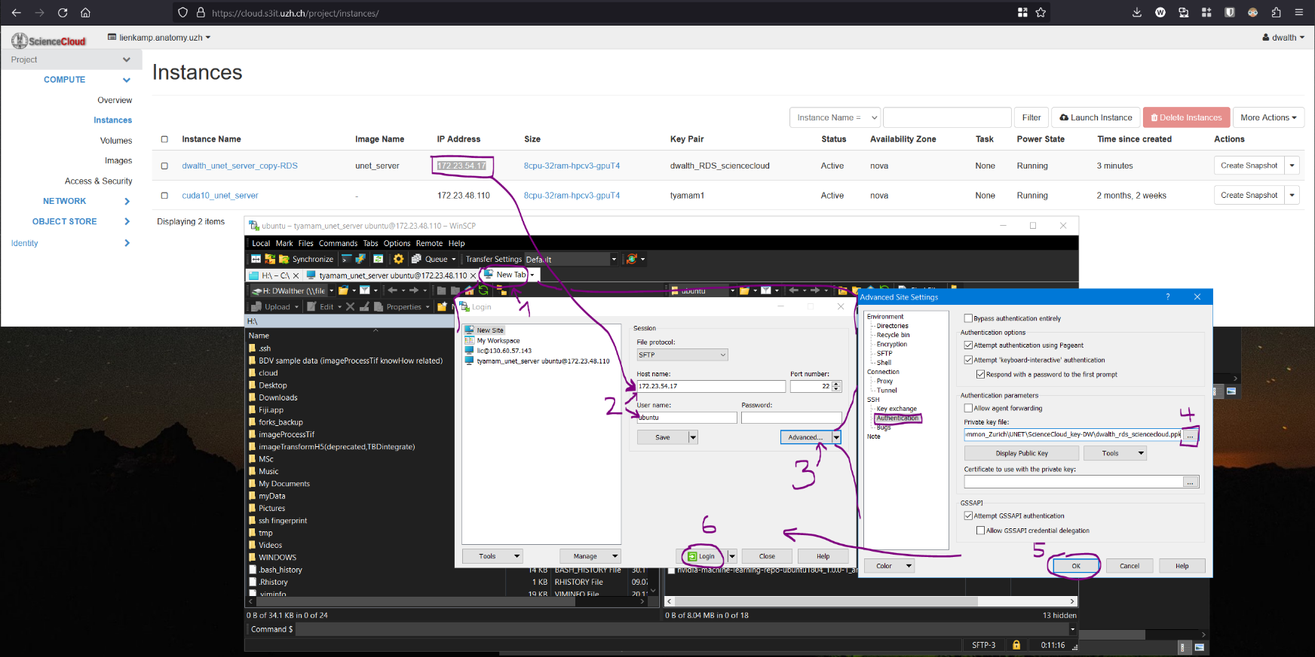

1. Open WinSCP, click on new tab.
2. login on <https://cloud.s3it.uzh.ch>, lookup the IP of the cloud instance you want to connect to, enter this IP in the WinSCP window for connecting to a new server (when clicking on “New Tab”).
   1. User name has to be “ubuntu” in the case of the unet_server – identical to the unicorn fiji unet connection settings.
3. Click on “Advanced…”
4. Click on “Authenticate” and choose the location of the private ssh key - Y:\Info\Common_Zurich\UNET\ScienceCloud_key-DW\dwalth_rds_sciencecloud.ppk - for connecting to the cloud server instance.
5. Click “OK”
6. Click “Login”

Now the connection should have been made, you should see the file system opened on the right half of the WinSCP window.

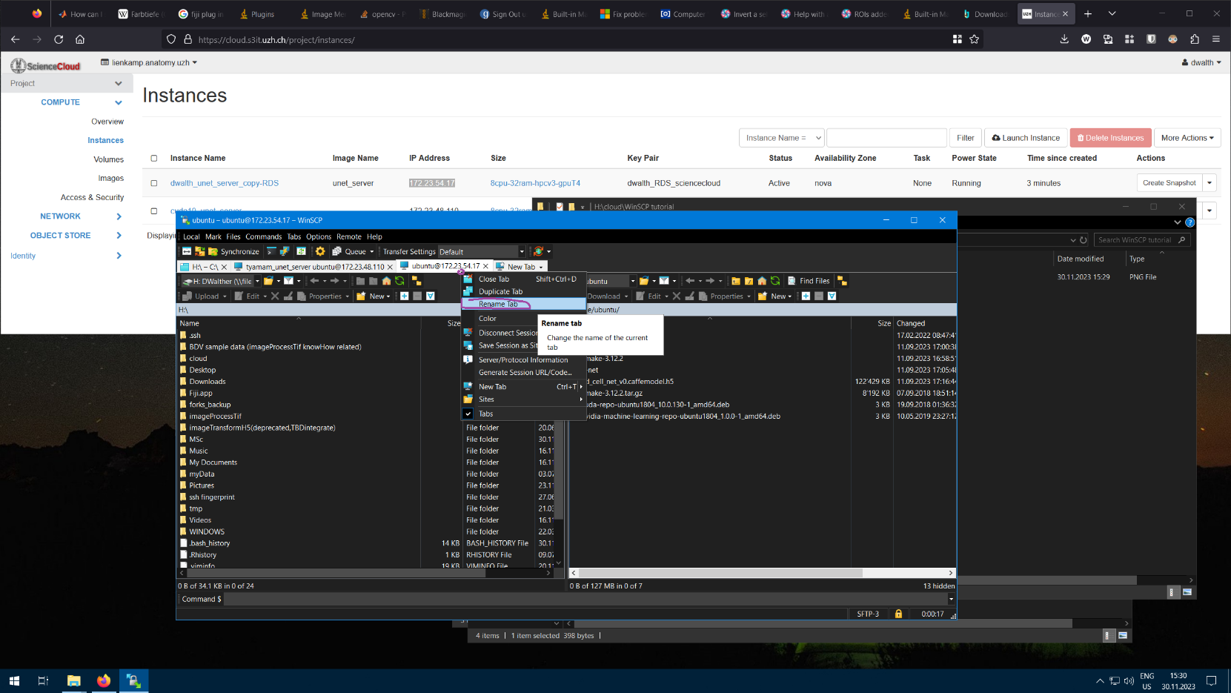

Right click on the newly created tab to rename it to something more meaningful, if you wish.

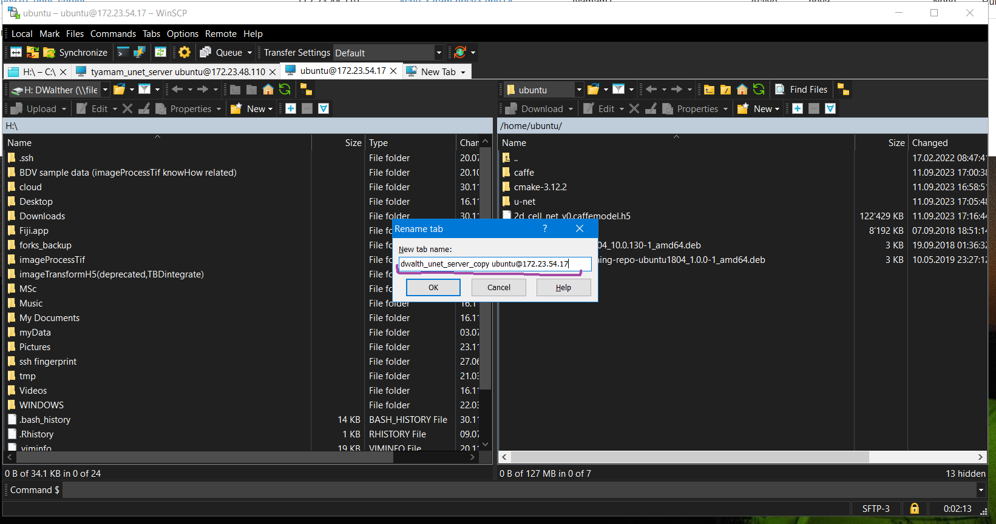

Pick a sensible name that you recognize later on when using WinSCP again.

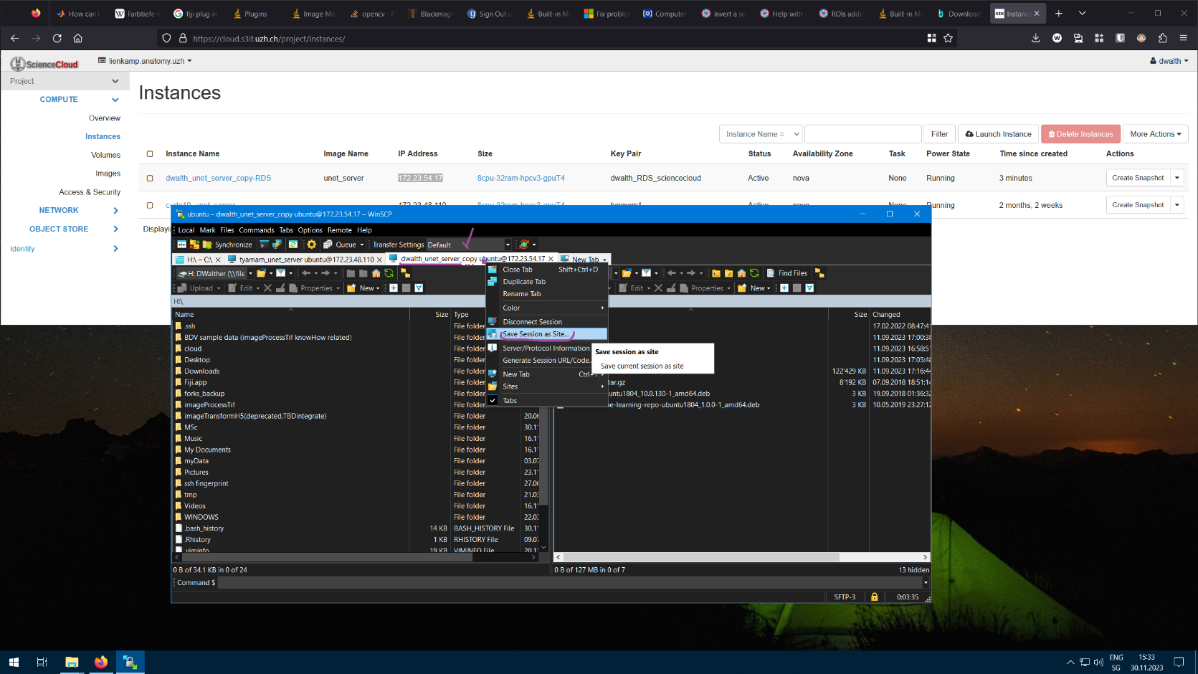

In order not to have to configure the connection again every next time you use WinSCP, you can right click on the newly created Tab and save it, so WinSCP remembers it and offers it to you in a list when you re-open WinSCP.

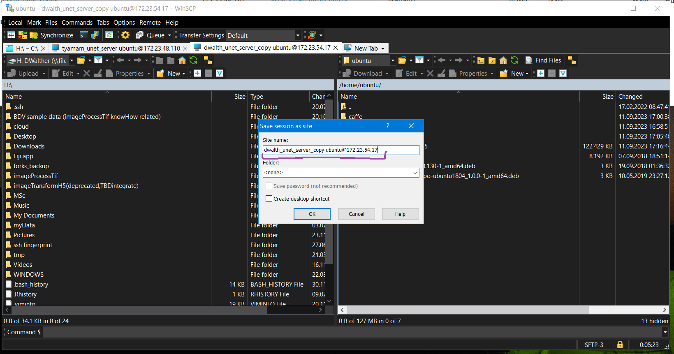

Again, pick a name that is meaningful to you.

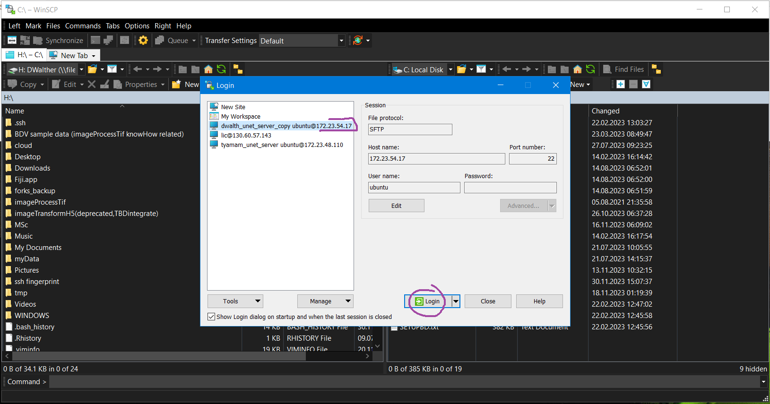

This is how it should then look when you re-open WinSCP some other time. Choose the session you want to connect to on the left and click on “Login”.

The same window & list appear when pressing on “New Tab” like in the very first step (1.).

Tutorial by Daniel Walther from 30.11.2023 (for contacting should something not work at some point in the future).